{{DATE}}

**{{CLIENT_NAME}}**

**{{ADDRESS}}**

**ATTENTION: {{CONTACT_PERSON}}**

Dear Sir/Madam,  
  
We take special pleasure in submitting our firm quotation for the KYOCERA DIGITAL COPIER TASKalfa 2321 as follows:

**BLACK ‘n WHITE COPY & PRINT, COLORED SCAN**

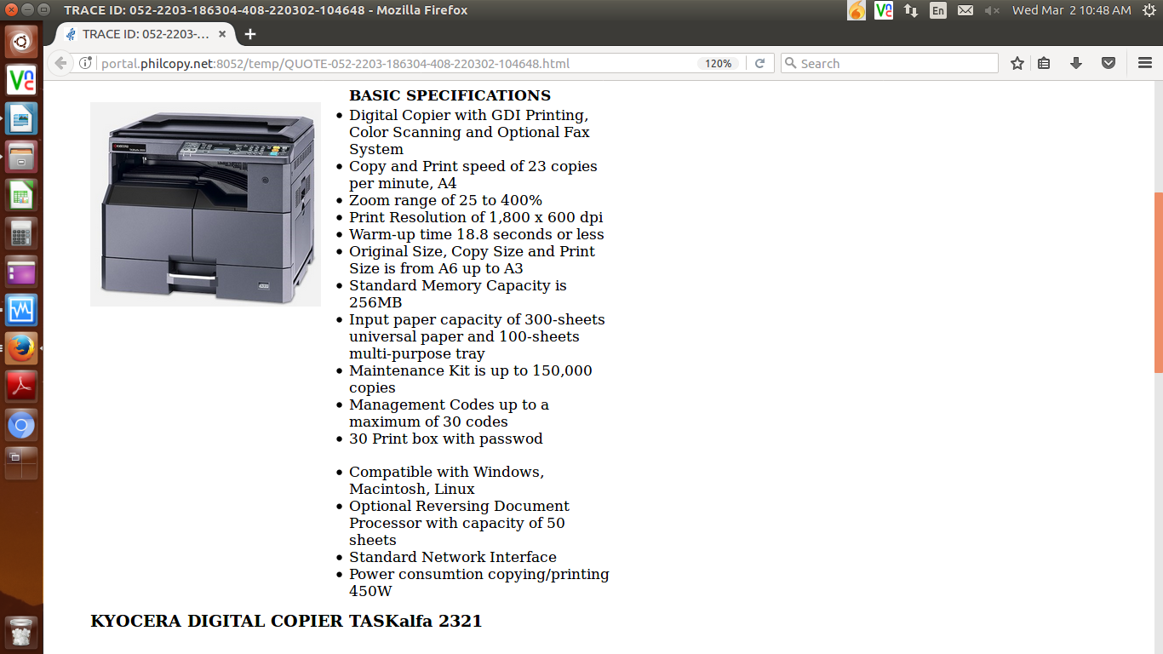

**PRICE:**

|  |  |  |
| --- | --- | --- |
| 1 unit of KYOCERA DIGITAL COPIER TASKalfa 2321 | Php | **125,000.00** |

**PROMO**

MACHINE PRICE: Php 125,000.00

LESS PROMO DISCOUNT Php 40,760.00

**TOTAL AMOUNT Php 84,240.00**

**OPTIONAL**

AUTO-FEEDER Php 28,250.00

ADDITIONAL PAPER CASSETTE Php 16,450.00

STEEL TABLE/CABINET Php 6,700.00

3 YEARS SERVICE WARRANTY EXTENSION Php 6,600.00

**COST PER PAGE**

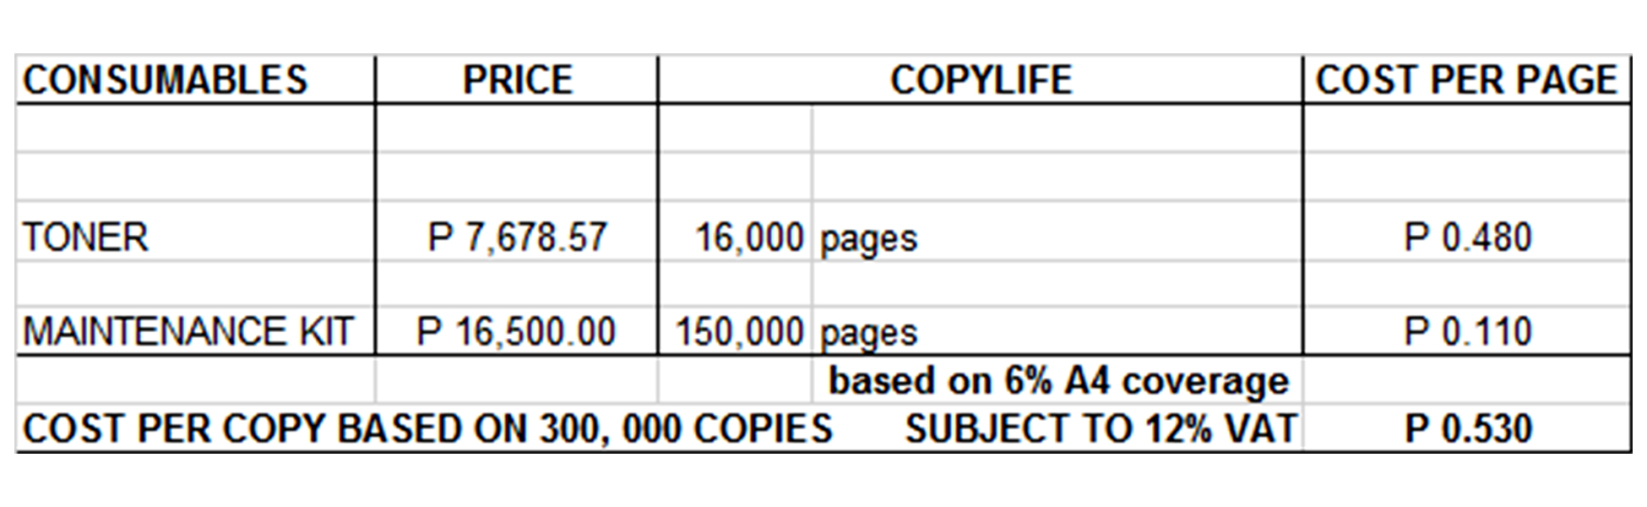

**Terms of Payment:** CASH  
  
**VALIDITY:** Prices are subject to change without prior notice, please confirm with us prior to finalization of order.  
  
**WARRANTY:**   
  
KYOCERA DIGITAL PLAIN PAPER COPIERS are guaranteed on spare parts replacement FREE OF CHARGE for ONE (1) year, or up to 150,000 copies/print/scan whichever comes first.  
  
Warranty for accessories and options is ONE (1) year from date of delivery.  
  
We also assure you prompt service whenever you need assistance. Repair service is FREE for TWO (2) years within Metro Manila. Should our machine require prolonged service, we shall install a back-up unit immediately for your convenience.  
  
Installation and Training of Personnel: Our expert service engineers install all our machines and they will be glad to train interested personnel on the detailed mechanics of the machine free of charge.

Moreover, the amount quoted above excludes the cost of any required tests or medical certifications such as, but not limited to Rapid test, Antigen test, RT-PCR test. The actual cost will be billed separately.

We are looking forward to hearing from you soon. For any questions or concerns, please feel free to call us at 7618-0274.  
  
  
Very truly yours, Conforme:  
  
  
**JAYPEE SONIEL _______________________________________**  
ACCOUNT EXECUTIVE III

0917-624-0820

(02)7618-0274